Timoshenko formula for u_theta evaluated for: r=a and theta=0, 30, 60, 90 degrees
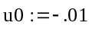
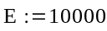
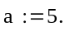
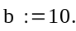
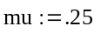
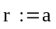
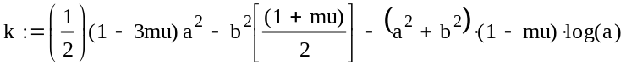
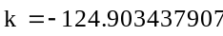
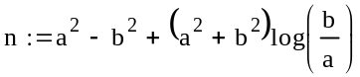
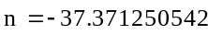
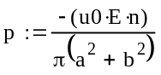
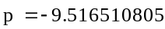
theta = 0 degree
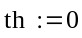
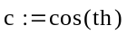
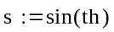
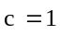
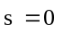
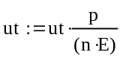
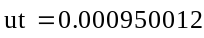
theta = 30 degree
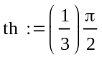
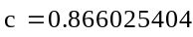
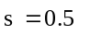
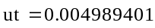
theta = 60 degree
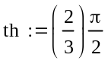
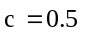
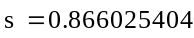
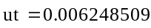
theta = 90 degree
